1. **Create a Spring Web Project using Maven**

**Code:**

package com.cognizant.spring_learn;

import org.springframework.boot.SpringApplication;

import org.springframework.boot.autoconfigure.SpringBootApplication;

*@SpringBootApplication*

public class SpringLearnApplication {

public static void main(String[] args) {

SpringApplication.*run*(SpringLearnApplication.class, args);

}

}

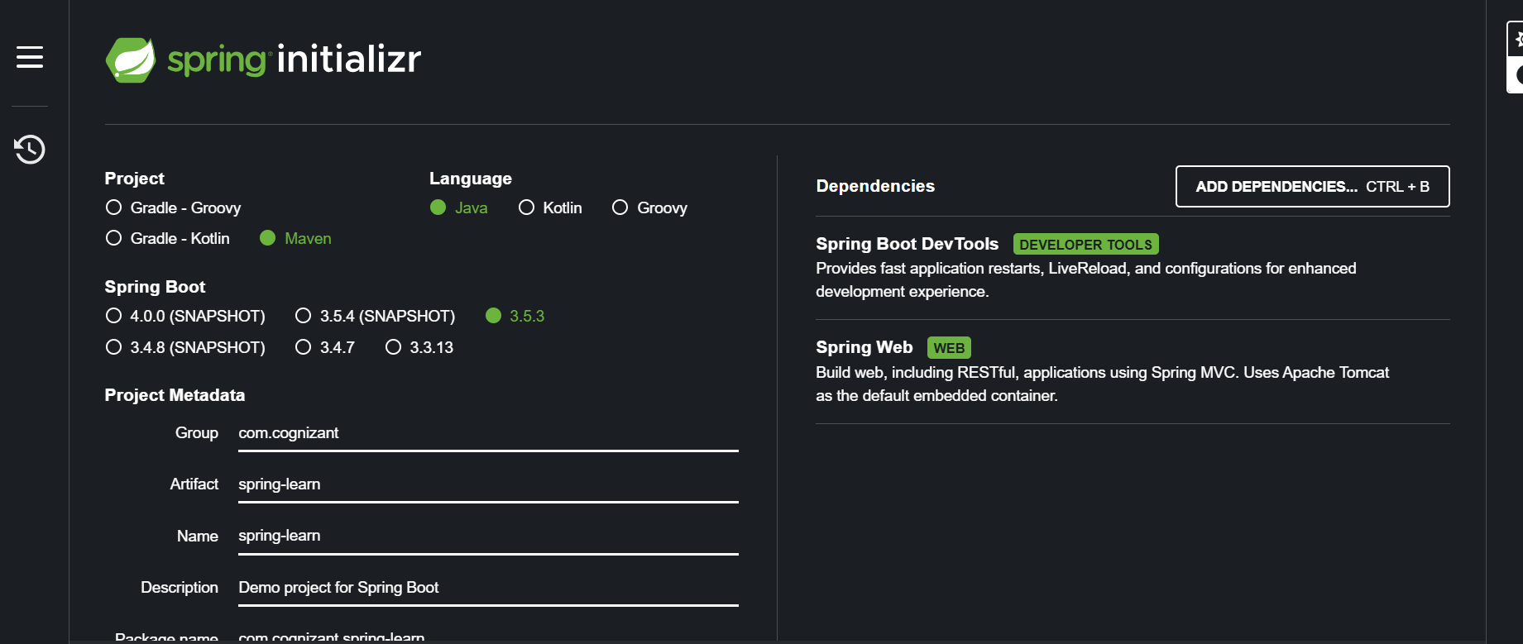

**Output**

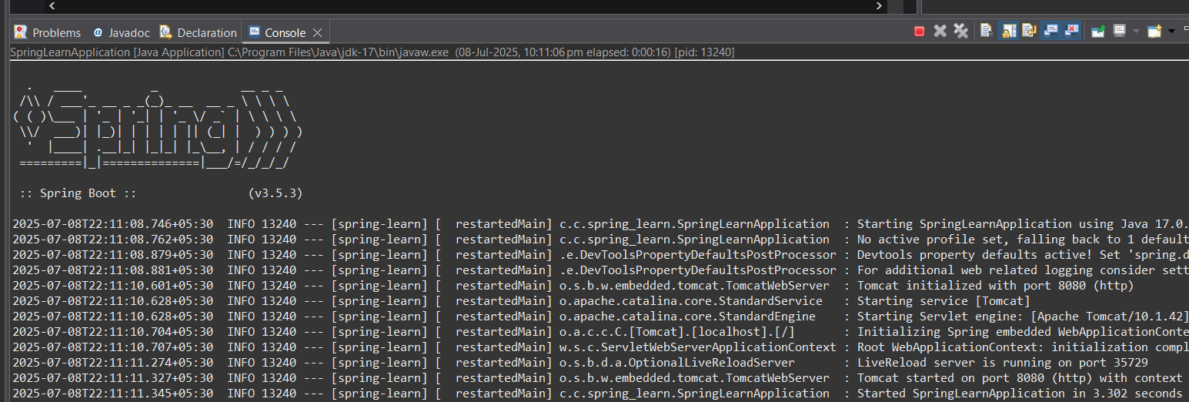

**4) Spring Core – Load Country from Spring Configuration XML**

**Code:**

Pom.xml

<?xml version="1.0" encoding="UTF-8"?>

<project xmlns="http://maven.apache.org/POM/4.0.0" xmlns:xsi="http://www.w3.org/2001/XMLSchema-instance"

xsi:schemaLocation="http://maven.apache.org/POM/4.0.0 https://maven.apache.org/xsd/maven-4.0.0.xsd">

<modelVersion>4.0.0</modelVersion>

<parent>

<groupId>org.springframework.boot</groupId>

<artifactId>spring-boot-starter-parent</artifactId>

<version>3.5.3</version>

<relativePath/> <!-- lookup parent from repository -->

</parent>

<groupId>com.cognizant</groupId>

<artifactId>spring-learn</artifactId>

<version>0.0.1-SNAPSHOT</version>

<name>spring-learn</name>

<description>Demo project for Spring Boot</description>

<url/>

<licenses>

<license/>

</licenses>

<developers>

<developer/>

</developers>

<scm>

<connection/>

<developerConnection/>

<tag/>

<url/>

</scm>

<properties>

<java.version>17</java.version>

</properties>

<dependencies>

<!-- Spring Boot Web Starter (REST APIs and embedded server) -->

<dependency>

<groupId>org.springframework.boot</groupId>

<artifactId>spring-boot-starter-web</artifactId>

</dependency>

<!-- Lombok for easy getters/setters (optional) -->

<dependency>

<groupId>org.projectlombok</groupId>

<artifactId>lombok</artifactId>

<scope>provided</scope>

</dependency>

</dependencies>

<build>

<plugins>

<plugin>

<groupId>org.springframework.boot</groupId>

<artifactId>spring-boot-maven-plugin</artifactId>

</plugin>

</plugins>

</build>

</project>

country.xml

<?xml version="1.0" encoding="UTF-8"?>

<beans xmlns="http://www.springframework.org/schema/beans"

xmlns:xsi="http://www.w3.org/2001/XMLSchema-instance"

xsi:schemaLocation="http://www.springframework.org/schema/beans

http://www.springframework.org/schema/beans/spring-beans.xsd">

<bean id="country" class="com.cognizant.spring_learn.Country">

<property name="code" value="IN"/>

<property name="name" value="India"/>

</bean>

</beans>

Country.java

package com.cognizant.spring_learn;

public class Country {

private String code;

private String name;

public Country() {}

public Country(String code, String name) {

this.code = code;

this.name = name;

}

public String getCode() { return code; }

public void setCode(String code) { this.code = code; }

public String getName() { return name; }

public void setName(String name) { this.name = name; }

}

SpringLearnApplication.java

package com.cognizant.spring_learn;

import org.springframework.boot.SpringApplication;

import org.springframework.boot.autoconfigure.SpringBootApplication;

import org.springframework.web.bind.annotation.GetMapping;

import org.springframework.web.bind.annotation.RestController;

*@SpringBootApplication*

*@RestController*

public class SpringLearnApplication { ApplicationContext context=null;

public static void main(String[] args) {

SpringApplication.*run*(SpringLearnApplication.class, args);

}

*@GetMapping*("/country")

public Country getCountry() {

// Load the bean from XML on every request (or you could cache it)

if(context==null)

context = new ClassPathXmlApplicationContext("country.xml");

Country country = context.getBean("country", Country.class);

return country;

}

}

